1- Prepare Kubeadm env ( EC2s on AWS )
2- Docker ( Manual Installation )
3- Nodejs app
4- Prometheus & Grafana( Manual Installation )

ubuntu@masternode:~$ kubectl get ns
NAME STATUS AGE
default Active 3h22m
kube-flannel Active 3h21m
kube-node-lease Active 3h22m
kube-public Active 3h22m
kube-system Active 3h22m
monitoring Active 3h17m

Open the required ports using kubectl expose commands.

ubuntu@masternode:~$ kubectl get svc -n monitoring
NAME TYPE CLUSTER-IP EXTERNAL-IP PORT(S) AGE
alertmanager-operated ClusterIP None <none> 9093/TCP,9094/TCP,9094/UDP 3h17m
prometheus-grafana ClusterIP 10.105.94.63 <none> 80/TCP 3h17m
prometheus-grafana-ext NodePort 10.111.141.235 <none> 80:30403/TCP 3h7m
prometheus-kube-prometheus-alertmanager ClusterIP 10.103.161.117 <none> 9093/TCP,8080/TCP 3h17m
prometheus-kube-prometheus-alertmanager-ext NodePort 10.102.253.183 <none> 9093:32677/TCP,8080:30930/TCP 171m
prometheus-kube-prometheus-operator ClusterIP 10.107.215.193 <none> 443/TCP 3h17m
prometheus-kube-prometheus-prometheus ClusterIP 10.99.167.195 <none> 9090/TCP,8080/TCP 3h17m
prometheus-kube-prometheus-prometheus-ext NodePort 10.108.204.107 <none> 9090:30238/TCP,8080:31353/TCP 3h11m
prometheus-kube-state-metrics ClusterIP 10.98.129.203 <none> 8080/TCP 3h17m
prometheus-operated ClusterIP None <none> 9090/TCP 3h17m
prometheus-prometheus-node-exporter ClusterIP 10.98.156.62 <none> 9100/TCP 3h17m

Access the Prometheus and Grafana UIs using IP:NodePort. (Grafana password: prom--operator)

ubuntu@masternode:~$ mkdir nodejs
ubuntu@masternode:~$ cd nodejs/
ubuntu@masternode:~/nodejs$

ubuntu@masternode:~$ vim index.js

const express = require('express'); // web framework to create a lightweigh server
const client = require('prom-client'); // prometheus library to collect metrcis

const app = express();
const port = 3000; // open port 3000

// Create a Registry to register the metrics
const register = new client.Registry();

// Add a default label which is added to all metrics
register.setDefaultLabels({
app: 'nodejs_system_app'
});

// Enable the collection of default metrics
client.collectDefaultMetrics({ register }); // Memory – Cpu – event loop lag – gc state

// Define a custom metric for total HTTP requests to the root path
const rootHttpRequestCounter = new client.Counter({
name: 'http_requests_root_total',
help: 'Total number of HTTP requests to the root path',
});

// Register the custom metric
register.registerMetric(rootHttpRequestCounter);

// Middleware to count every request to the root path
app.use((req, res, next) => {
if (req.path === '/') {
rootHttpRequestCounter.inc();
}
next();
});

// Define a route for Prometheus to scrape
app.get('/metrics', async (req, res) => { // open the endpoint /metrics that store information
res.set('Content-Type', register.contentType);
res.end(await register.metrics());
});

// Define the root route
app.get('/', (req, res) => {
res.send('Hello From Node.js app Test');
});

// Start the server
app.listen(port, () => {
console.log(`Example app listening at http://localhost:${port}`);
});

ubuntu@masternode:~$ vim Dockerfile

FROM node:lts
WORKDIR /usr/src/app
COPY . .
RUN npm install express prom-client
EXPOSE 3000
CMD ["node", "index.js"]

ubuntu@masternode:~/nodejs$ docker build -t nodejs-app-prom .
[+] Building 5.1s (9/9) FINISHED docker:default
=> [internal] load build definition from Dockerfile 0.0s
=> => transferring dockerfile: 156B 0.0s
=> [internal] load metadata for docker.io/library/node:lts 0.4s
=> [internal] load .dockerignore 0.0s
=> => transferring context: 2B 0.0s
=> [1/4] FROM docker.io/library/node:lts@sha256:e515259afd26f60db74957c62203c93d45760f2ba864d94accfa2edfc1ac17cf 0.0s
=> [internal] load build context 0.0s
=> => transferring context: 184B 0.0s
=> CACHED [2/4] WORKDIR /usr/src/app 0.0s
=> [3/4] COPY . . 0.0s
=> [4/4] RUN npm install express prom-client 4.1s
=> exporting to image 0.4s
=> => exporting layers 0.4s
=> => writing image sha256:21391370b13e5047165456ae10376cce0ea6f1161ece3b2f4d73639e5bbb09dd 0.0s
=> => naming to docker.io/library/nodejs-app-prom 0.0s

ubuntu@masternode:~/nodejs$ docker images
REPOSITORY TAG IMAGE ID CREATED SIZE
nodejs-app-prom latest 21391370b13e About a minute ago 1.14GB

ubuntu@masternode:~/nodejs$ docker tag nodejs-app-prom:latest aliaceofali/nodejs-app-prom:v1

ubuntu@masternode:~/nodejs$ docker images
REPOSITORY TAG IMAGE ID CREATED SIZE
aliaceofali/nodejs-app-prom v1 21391370b13e About a minute ago 1.14GB ## check for tag
nodejs-app-prom latest 21391370b13e About a minute ago 1.14GB

docker login
Login Succeeded
## verification

ubuntu@masternode:~/nodejs$ docker push aliaceofali/nodejs-app-prom:v1
The push refers to repository [docker.io/aliaceofali/nodejs-app-prom]
f515febcb2f4: Pushed
7617c43270a7: Pushed
8735979c33fc: Pushed
e5b77f05d0e5: Mounted from library/node
bd8201ae8f5d: Mounted from library/node
16af5fc601df: Mounted from library/node
2f10455f8757: Mounted from library/node
1b90aaaeb596: Mounted from library/node
a9b908787288: Mounted from library/node
20c8aca21338: Mounted from library/node
175a19836175: Mounted from library/node
v1: digest: sha256:6b99fe3af88641a2eb4d0de2f8bc95122127efa37d93a188ca4ebc915880afe1 size: 2630

Check your image on your DockerHub account.

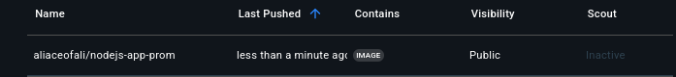

Deployment Steps
- Create a deployment.
- Expose it and check access using the NodePort.

ubuntu@masternode:~/nodejs$ kubectl get deploy
No resources found in default namespace.

ubuntu@masternode:~/nodejs$ kubectl get po
No resources found in default namespace.

ubuntu@masternode:~$ vim nodejs-app.yaml

apiVersion: apps/v1
kind: Deployment
metadata:
name: nodejs-app
spec:
replicas: 3
selector:
matchLabels:
app: nodejs
template:
metadata:
labels:
app: nodejs
spec:
containers:
- name: nodejs
image: aliaceofali/nodejs-app-prom:v1
ports:
- containerPort: 3000

ubuntu@masternode:~/nodejs$ kubectl apply -f nodejs-app.yaml
deployment.apps/nodejs-app created

ubuntu@masternode:~/nodejs$ kubectl get deploy
NAME READY UP-TO-DATE AVAILABLE AGE
nodejs-app 3/3 3 3 27s

ubuntu@masternode:~/nodejs$ kubectl get rs
NAME DESIRED CURRENT READY AGE
nodejs-app-8549c8b8db 3 3 3 29s

ubuntu@masternode:~/nodejs$ kubectl get po
NAME READY STATUS RESTARTS AGE
nodejs-app-8549c8b8db-cjj7v 1/1 Running 0 23s
nodejs-app-8549c8b8db-twmrn 1/1 Running 0 23s
nodejs-app-8549c8b8db-zgk5q 1/1 Running 0 23s

----

apiVersion: v1
kind: Service
metadata:
name: nodejs-svc
labels:
app: nodejs
annotations:
prometheus.io/scrape: "true" # Enable scraping for Prometheus
spec:
type: NodePort
selector:
app: nodejs
ports:
- port: 3000
targetPort: 3000
name: http-nodejs-app

ubuntu@masternode:~/nodejs$ kubectl apply -f nodejs-svc.yaml
service/nodejs-svc created

kubectl get svc
ubuntu@masternode:~/nodejs$ kubectl get svc
NAME TYPE CLUSTER-IP EXTERNAL-IP PORT(S) AGE
kubernetes ClusterIP 10.96.0.1 <none> 443/TCP 3h45m
nodejs-svc NodePort 10.97.14.36 <none> 3000:31557/TCP 11s

ip : 31557(NodePort)

Enable Prometheus to Monitor the Application (Not Just the Pods)

ubuntu@masternode:~/nodejs$ kubectl get po
NAME READY STATUS RESTARTS AGE
nodejs-app-8549c8b8db-cjj7v 1/1 Running 0 3m7s
nodejs-app-8549c8b8db-twmrn 1/1 Running 0 3m7s
nodejs-app-8549c8b8db-zgk5q 1/1 Running 0 3m7s

In the Prometheus UI, execute the query:
container_cpu_usage_seconds_total
- Use the Pod ID to search for results.
- You'll find how much CPU the application is using.
- Prometheus did not scrape metrics from the application — only from the pod itself.

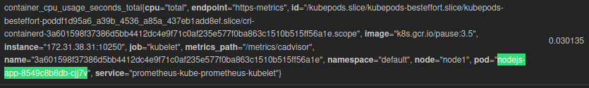

So let's tell Prometheus about the application by adding it as a new target.

To do this, we need to create a ServiceMonitor component in the Prometheus namespace.

ubuntu@masternode:~/nodejs$ kubectl get ns
NAME STATUS AGE
default Active 3h49m
kube-flannel Active 3h49m
kube-node-lease Active 3h49m
kube-public Active 3h49m
kube-system Active 3h49m
monitoring Active 3h44m

ubuntu@masternode:~/nodejs$ kubectl apply -f nodejs-monitor.yaml

apiVersion: monitoring.coreos.com/v1
kind: ServiceMonitor
metadata:
name: nodejs-monitor
namespace: monitoring # Ensure this matches your monitoring namespace
labels:
release: prometheus # Adjust if you use a different labels ( depends on system )
spec:
selector:
matchLabels:
app: nodejs # Match the label used in your nodejs-app.yaml
namespaceSelector:
matchNames:
- default # where your nodejs-svc is deployed
endpoints:
- port: http-nodejs-app # Match the name of the port in your nodejs-svc.yaml
path: /metrics # Path to scrape metrics from

ubuntu@masternode:~/nodejs$ kubectl apply -f nodejs-monitor.yaml
servicemonitor.monitoring.coreos.com/nodejs-monitor created

Open Prometheus and check the Targets page to see if the new application endpoint is added.
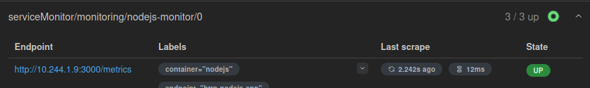

ubuntu@masternode:~/nodejs$ kubectl get po -o wide
NAME READY STATUS RESTARTS AGE IP NODE NOMINATED NODE READINESS GATES
nodejs-app-8549c8b8db-cjj7v 1/1 Running 0 11m 10.244.1.9 node1 <none> <none>
nodejs-app-8549c8b8db-twmrn 1/1 Running 0 11m 10.244.2.8 node2 <none> <none>
nodejs-app-8549c8b8db-zgk5q 1/1 Running 0 11m 10.244.2.9 node2 <none> <none>

You’ll find the endpoint listed under Targets, along with its IP.
Now Prometheus can monitor both the pod and the application inside it.

Add a New Target Using ServiceMonitor
- The prometheus-operator will automatically discover and start scraping the new target.

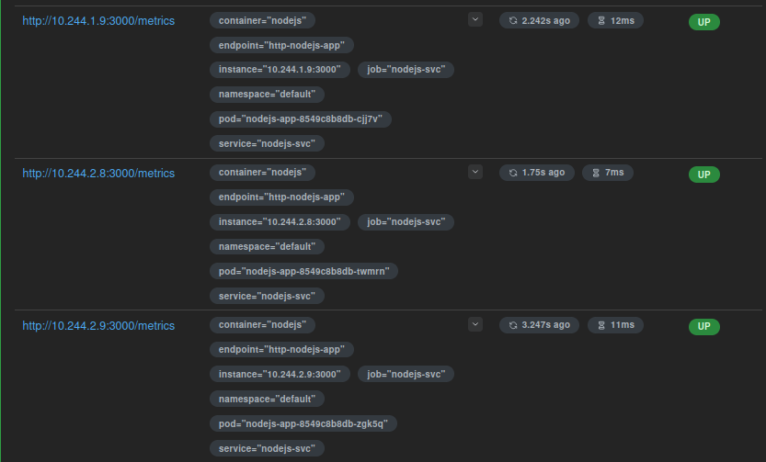

Create a Rule
- Let’s now create an alerting rule.
- You can check configured rules in the UI under Alerts/Rules.
- Configure the rule to send alerts to Slack.
- Create a Bash script to send many requests to the application, simulating stress or load.
- Observe the behavior in the UI — even in networking namespaces if applicable.

apiVersion: monitoring.coreos.com/v1
kind: PrometheusRule
metadata:
name: nodejs-alerts
namespace: monitoring # Ensure this matches your monitoring namespace
labels:
app: kube-prometheus-stack
release: prometheus # it must match the label used in your Prometheus default configuration
spec:
groups:
- name: nodejs.alert # Name of the alert group
rules:
- alert: HighRequestRate_NodeJS
expr: rate(http_requests_root_total[5m]) > 10 # expression means high request rate
for: 0m
labels:
app: nodejs
namespace: monitoring # Ensure this matches your monitoring namespace
annotations:
summary: "High request rate detected in Node.js application"
description: "The Node.js application is receiving a high request rate ({{ $value }})"

ubuntu@masternode:~/nodejs$ kubectl apply -f nodejs-rule.yaml
prometheusrule.monitoring.coreos.com/nodejs-alerts created

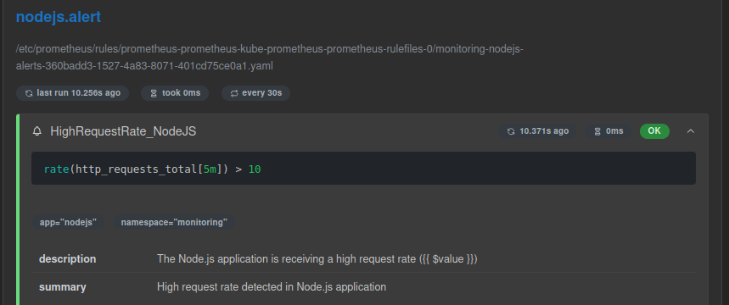

ubuntu@masternode:~/nodejs$ kubectl get secret -n monitoring
NAME TYPE DATA AGE
alertmanager-prometheus-kube-prometheus-alertmanager Opaque 1 3h56m
alertmanager-prometheus-kube-prometheus-alertmanager-cluster-tls-config Opaque 1 3h56m
alertmanager-prometheus-kube-prometheus-alertmanager-generated Opaque 1 3h56m
alertmanager-prometheus-kube-prometheus-alertmanager-tls-assets-0 Opaque 0 3h56m
alertmanager-prometheus-kube-prometheus-alertmanager-web-config Opaque 1 3h56m
prometheus-grafana Opaque 3 3h56m
prometheus-kube-prometheus-admission Opaque 3 3h56m
prometheus-prometheus-kube-prometheus-prometheus Opaque 1 3h56m
prometheus-prometheus-kube-prometheus-prometheus-thanos-prometheus-http-client-file Opaque 1 3h56m
prometheus-prometheus-kube-prometheus-prometheus-tls-assets-0 Opaque 1 3h56m
prometheus-prometheus-kube-prometheus-prometheus-web-config Opaque 1 3h56m
sh.helm.release.v1.prometheus.v1 helm.sh/release.v1 1 3h56m
slack-secret Opaque 1 3h6m

ubuntu@masternode:~/nodejs$ kubectl describe secret slack-secret -n monitoring
Name: slack-secret
Namespace: monitoring
Labels: <none>
Annotations: <none>

Type: Opaque

Data
====
webhook: 81 bytes

ubuntu@masternode:~/nodejs$ vim nodejs-alert-manager.yaml

apiVersion: monitoring.coreos.com/v1alpha1
kind: AlertmanagerConfig
metadata:
name: nodejs-alert-manager
namespace: monitoring # Ensure this matches your monitoring namespace
spec:
route:
receiver: 'nodejs-slack'
repeatInterval: 30m
routes:
- matchers:
- name: alert-https
value: HighRequestRate_NodeJS # Match the alert name you created in nodejs-rule.yaml
repeatInterval: 10m
receivers:
- name: 'nodejs-slack'
slackConfigs:
- apiURL:
key: webhook
name: slack-secret # Ensure this matches your secret name
channel: '#https_requests' # Adjust to your Slack channel
sendResolved: true

ubuntu@masternode:~/nodejs$ kubectl apply -f nodejs-alert-manager.yaml
alertmanagerconfig.monitoring.coreos.com/nodejs-alert-manager created

ubuntu@masternode: kubectl get alertmanagerconfig -n monitoring

ubuntu@masternode:~/nodejs$ kubectl get alertmanagerconfig -n monitoring
NAME AGE
nodejs-alert-manager 35s

ubuntu@masternode:~/nodejs$ kubectl get svc
NAME TYPE CLUSTER-IP EXTERNAL-IP PORT(S) AGE
kubernetes ClusterIP 10.96.0.1 <none> 443/TCP 4h12m
nodejs-svc NodePort 10.97.14.36 <none> 3000:31557/TCP 27m

ubuntu@masternode:~/nodejs$ vim forcerequests.sh

#!/bin/bash

send_requests() {
while true; do
curl -sS http://13.61.174.226:31557/ > /dev/null
echo "Request sent"
sleep 0.0667
done
}

for ((i=1; i<=15; i++)); do
send_requests &
pids[$i]=$!
done

trap 'echo "Exiting..."; kill ${pids[*]}; exit' INT

wait

ubuntu@masternode:~/nodejs$ sudo chmod +x forcerequests.sh
ubuntu@masternode:~/nodejs$ ./forcerequests.sh
Request sent
Request sent
Request sent

Add Visualization in Grafana
- Take the Prometheus query expression and add it to Grafana.
- Watch the graph showing your application's metrics in real-time.
- This helps you visualize request traffic and performance data.

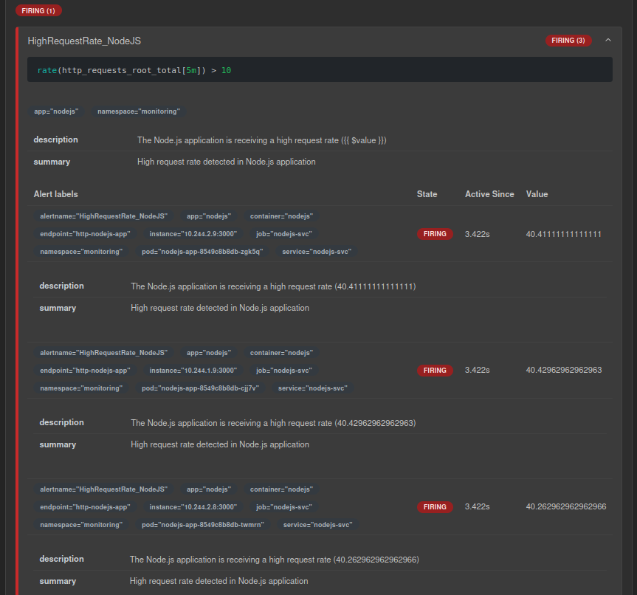

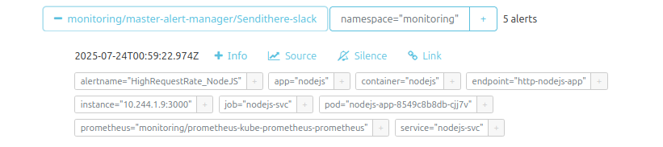

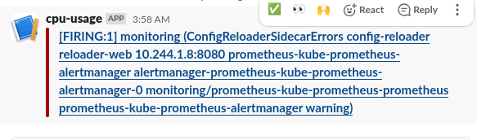
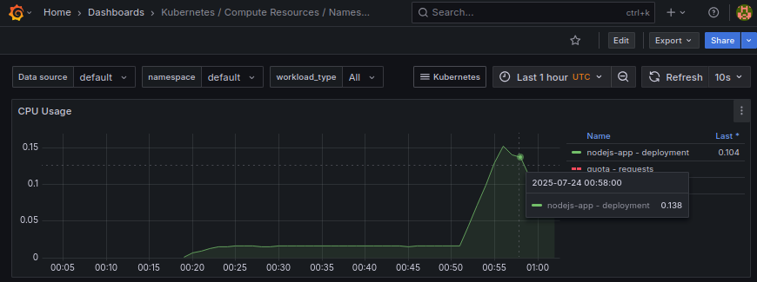

### let’s stop the script

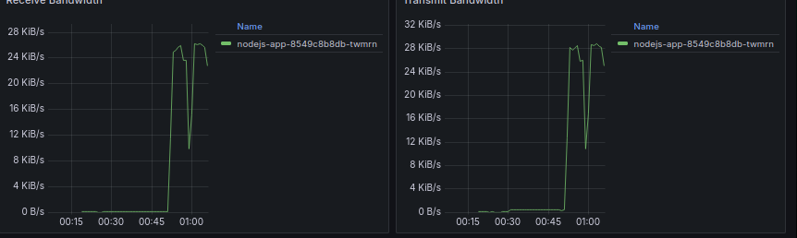

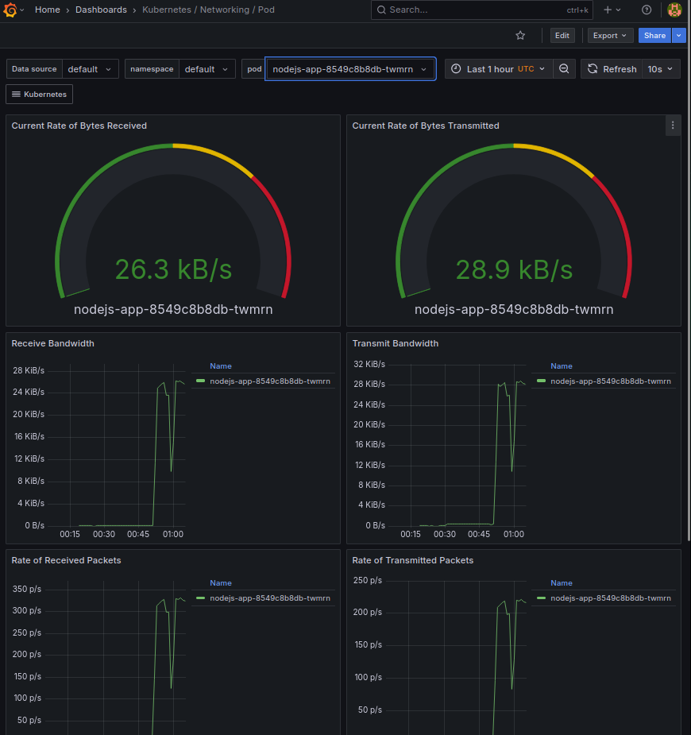

Stop the Bash Script
- Once the stress test is done, stop the script.
- Then check the Grafana graphs again to observe how the application metrics respond.

